**MA4605: Factorial Design and Interaction**

* Interaction Effects and Interaction Plots
* Factorial Design

**Two Way ANOVA : Example**

(This example is relevant to Randomized Block Design)

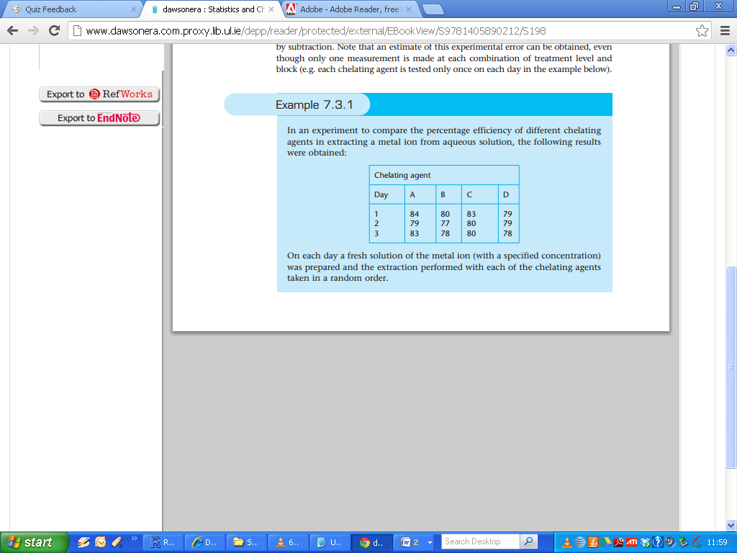

ln this experiment the use of different chelating agents is a controlled factor since the chelating agents are chosen by the experimenter. The day on which the experiment is performed introduces uncontrolled variation, caused both by changes in laboratory temperature, pressure, etc., and by slight differences in the concentration of the metal ion solution, i.e. the day is potentially a ***nuisance factor***.

ANOVA can be used either to test for a significant effect due to a controlled factor, or to estimate the variance of an uncontrolled factor. In this case, where both types of factor occur, two-way ANOVA can be used in both ways:

1. to test whether the different chelating agents have significantly different efficiencies; and
2. to test whether the day-to-day variation is significantly greater than the variation due to the random error of measurement and, if it is, to estimate the variance of this day-today variation.

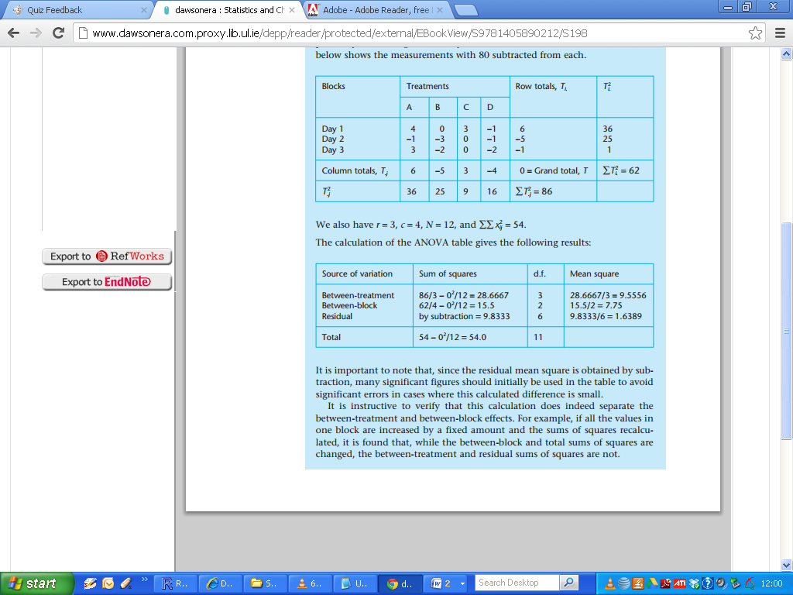

**Interactions**

ln the example used previously we saw that the two-way ANOVA calculations used assumed that the effects of the two factors (chelating agents and days) were ***additive***.

This means that if, for example, we had had only two chelating agents, A and B, and studied them both on each of two days, the results might have been something like:

|  |  |  |
| --- | --- | --- |
| Chelating agents | A | B |
| Day 1 | 80 | 82 |
| Day 2 | 77 | 79 |

That is, using chelating agent B instead of A produces an increase of 2% in extraction efficiency on both days; and the extraction efficiency on day 2 is lower than that on day 1 by 3%, whichever chelating agent is used.

In a simple table of the kind shown, this means that when three of the measurements are known, the fourth can easily be deduced (i.e. using rules of thumb as in last paragraph)

Suppose, however, that the extraction efficiency on day 2 for

chelating agent B had been 83% instead of 79%. Then we would conclude that the difference between the two agents depended on the day of the measurements, or that the difference between the results on the two days depended on which agent was in use.

That is, there would be an interaction between the two factors affecting the results. Such interactions are in practice extremely important: a recent estimate suggests that at least two-thirds of the processes in the chemical industry are affected by interacting, as opposed to additive, factors.

**Detection of Interactions**

Unfortunately the detection of interactions is not quite so simple as the above example implies, as the situation is confused by the presence of random errors. lf a two-way ANOVA calculation is applied to the very simple data above, the residual sum of squares (SSE in the ANOVA table) will be found to be zero, but if any of the four values is altered this is no longer so.

With this design of experiment we cannot tell whether a non-zero residual sum of squares is due to random errors, to an interaction between the factors, or to both effects.

**Replication**

To resolve this problem the measurements in each cell must be replicated. The manner in which this is done is important: the measurements must be repeated in such a way that all the sources of random error are present in every case. Thus in our example if different glassware or other equipment items have been used in experiments on the different chelating agents, then the replicate measurements applied to each chelating agent on each day must also use different apparatus.

lf the same equipment is used for these replicates, clearly the random error in the measurements will be underestimated. lf the replicates are performed properly, the method by which the interaction sum of squares and the random error can be separated is illustrated by the following new example.

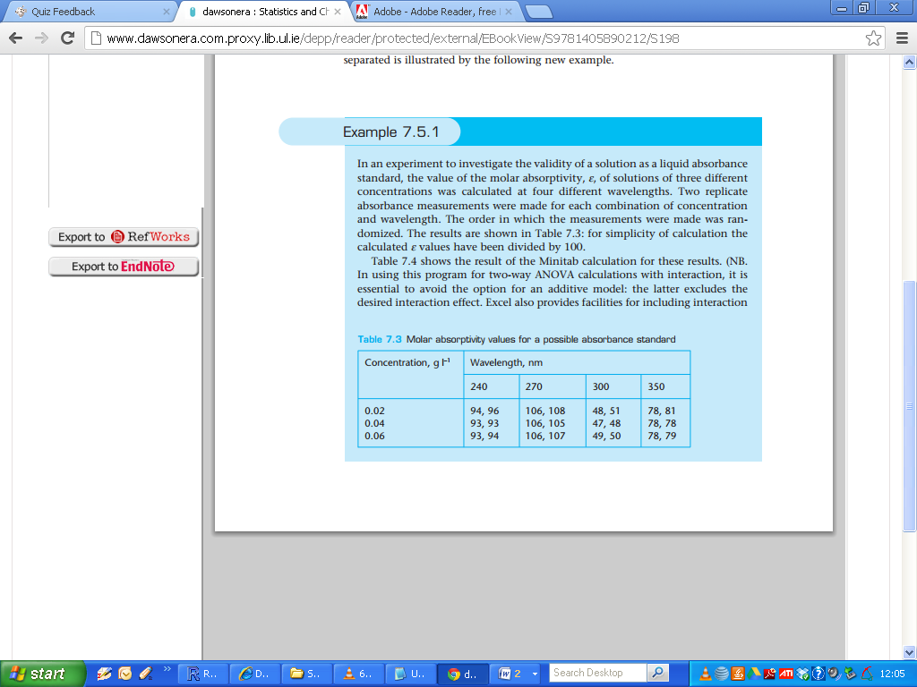

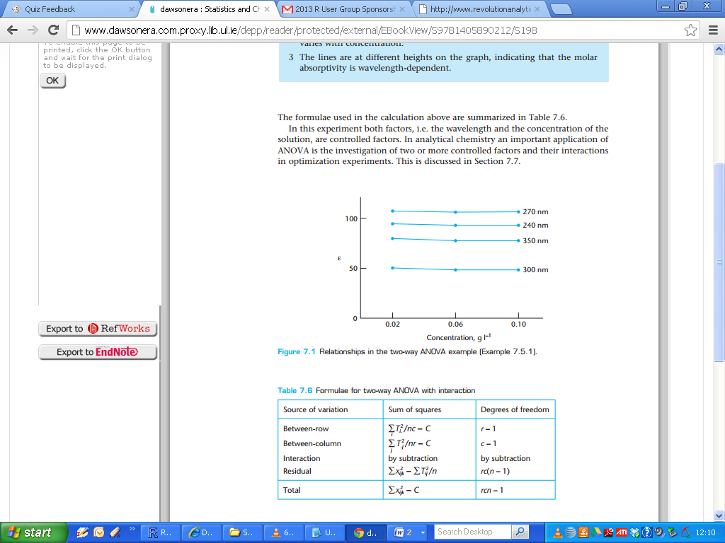

* T, Ti , Tj : Grand Total Row and Column Total
* n number of replicates
* r and c number of levels for each factor
* C correction term =T2/nrc

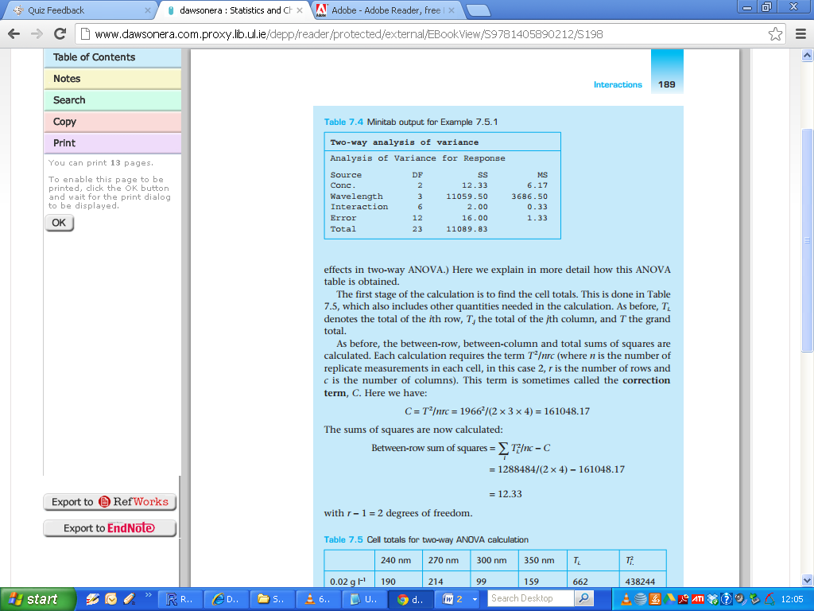

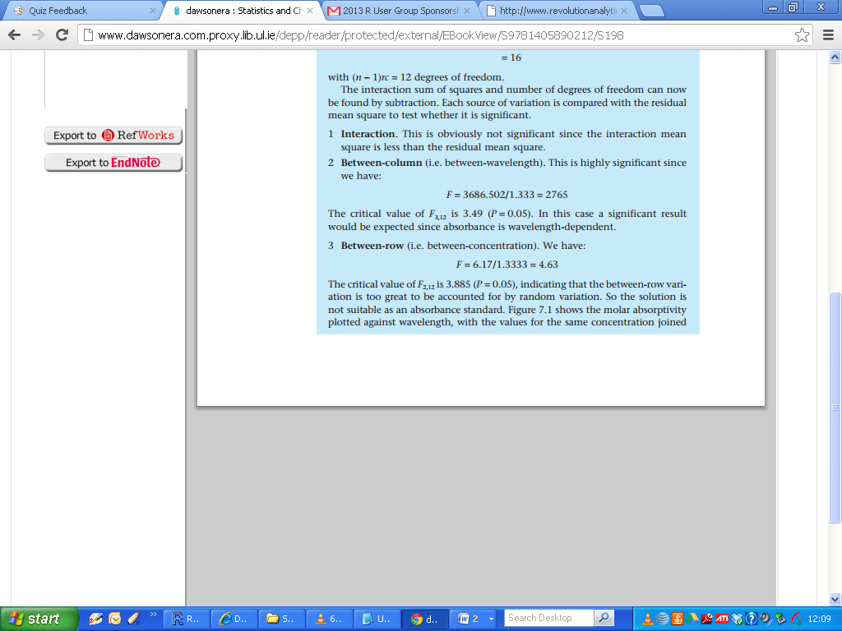

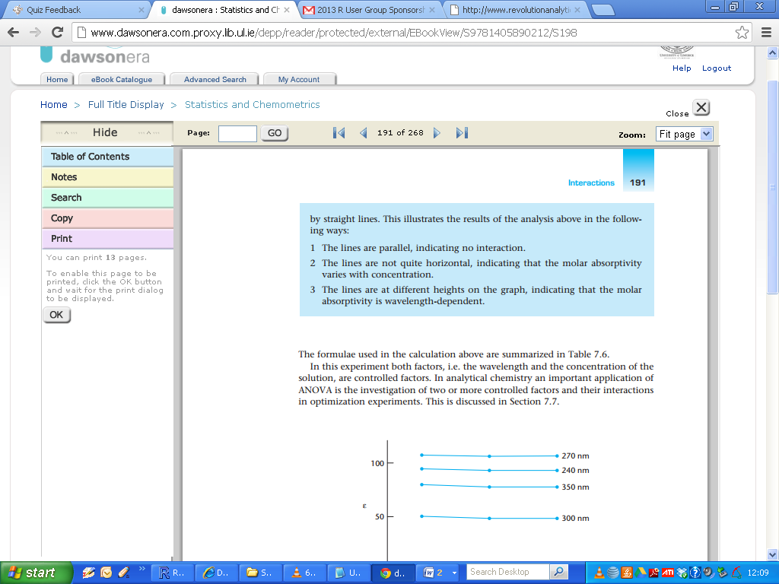

( I will revert to Interaction plots in next class)



**Factorial Design**

A study that has more than one independent variable is said to use a factorial design. (Recall, a “factor” is another name for an independent variable.)

Factorial designs are described using “***A x B***” notation, in which “***A***” stands for the number of levels of one independent variable and “***B***”

stands for the number of levels of the second independent variable.

In many cases, however, there are 2 levels for each factor, so we would say ***22 Design***. For k factors, each with two levels, we would refer to the design as ***2k Design.***

A factorial experiment is a statistical technique where two or more factors are being considered. In general, experimental trials (or runs) are performed for all combinations of factor level.

(Remark: Consider the case of a 7 factor experiment, this is equivalent to 128 runs. It may not be possible to get data for each combination.)

The ***effect*** of a factor is defined as the change in response produced by a change in the level of the factor. It is called a ***main effect*** because it refers to the primary factors in the study.

A “main effect” is the effect of one of your independent variables on the dependent variable, ignoring the effects of all other independent variables.